Exploring the Distributive Property Notes
You can find the total area of two rectangles by two methods.
Method 1: Find the area of each rectangle. Then find the sum of the areas. 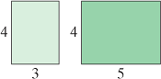

Method 2: Combine the two rectangles into one large rectangle. Find its length. Find its width. Then find its area.
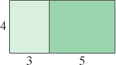

The total area of two rectangles can be represented by the following two expressions: $3∙4+5∙4 and \left(3+5\right)4 .$ Since both expressions have the same value, so they are equivalent. $3∙4+5∙4= \left(3+5\right)4$ . This equation is an example of the Distributive Property.

Distributive Property
To multiply a sum or difference, multiply each number within the parentheses by the number outside the parentheses.
$a\left(b+c\right)=ab+ac$ $2\left(3+5\right)=2\left(3\right)+2(5)$
$\left(b+c\right)a=ba+ca$ $\left(5+9\right)2=5∙2+9∙2$

